Lab – Troubleshooting Basic Frame Relay

1. Topology

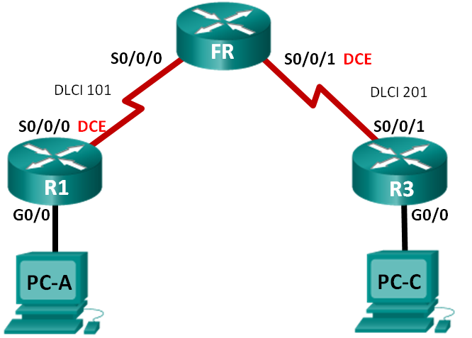

1. Addressing Table

|  |  |  |  |  |
| --- | --- | --- | --- | --- |
| Device | Interface | IP Address | Subnet Mask | Default Gateway |
| R1 | G0/0 | 192.168.1.1 | 255.255.255.0 | N/A |
|  | S0/0/0 (DCE) | 10.1.1.1 | 255.255.255.252 | N/A |
| FR | S0/0/0 | N/A | N/A | N/A |
|  | S0/0/1 (DCE) | N/A | N/A | N/A |
| R3 | G0/0 | 192.168.3.1 | 255.255.255.0 | N/A |
|  | S0/0/1 | 10.1.1.2 | 255.255.255.252 | N/A |
| PC-A | NIC | 192.168.1.3 | 255.255.255.0 | 192.168.1.1 |
| PC-C | NIC | 192.168.3.3 | 255.255.255.0 | 192.168.3.1 |

1. Objectives

Part 1: Build the Network and Load Device Configurations

Part 2: Troubleshoot Layer 3 Connectivity

Part 3: Troubleshoot Frame Relay

1. Background / Scenario

Frame Relay is a WAN protocol that operates at the physical and data link layers of the OSI reference model. Unlike leased lines, Frame Relay requires only a single-access circuit to the Frame Relay provider to communicate with multiple sites that are connected to the same provider. Configuring Frame Relay at the customer site is generally simple; however, configuration problems can occur.

In this lab, R1 and R3 are experiencing problems communicating with each other. EIGRP is not working and there may also be problems with the Frame Relay configuration. You have been assigned the job of finding and correcting all problems on R1 and R3.

**Note**: The routers used with CCNA hands-on labs are Cisco 1941 Integrated Services Routers (ISRs) with Cisco IOS Release 15.2(4)M3 (universalk9 image). Other routers and Cisco IOS versions can be used. Depending on the model and Cisco IOS version, the commands available and output produced might vary from what is shown in the labs. Refer to the Router Interface Summary Table at the end of this lab for the correct interface identifiers.

**Note**: Make sure that the routers have been erased and have no startup configurations. If you are unsure, contact your instructor.

**Note**: The FR router is acting as the Frame Relay switch, It does NOT have any configuration issues for you to troubleshoot.

1. Required Resources

* 3 Routers (Cisco 1941 with Cisco IOS Release 15.2(4)M3 universal image or comparable)
* 2 PCs (Windows 7, Vista, or XP with terminal emulation program, such as Tera Term)
* Console cables to configure the Cisco IOS devices via the console ports
* Ethernet and serial cables as shown in the topology

1. Build the Network and Load Device Configurations
   1. Cable the network as shown in the topology.
   2. Configure addressing on the PCs.
   3. Load router configuration files.

Load the following configurations into the appropriate router. R1 and R3 have the same passwords. The encrypted privileged EXEC mode password is **class**, and the password for console and vty access is **cisco**.

Router R1 Configuration:

hostname R1

enable secret class

no ip domain lookup

interface GigabitEthernet0/0

ip address 192.168.1.1 255.255.255.0

interface Serial0/0/0

ip address 10.1.1.5 255.255.255.252

encapsulation frame-relay

clock rate 128000

frame-relay map ip 10.1.1.2 101

no frame-relay inverse-arp

no shutdown

router eigrp 1

network 10.1.0.0 0.0.0.3

network 192.168.1.0

eigrp router-id 1.1.1.1

no auto-summary

line con 0

password cisco

logging synchronous

login

line vty 0 4

password cisco

login

end

Router R3 Configuration:

hostname R3

enable secret class

no ip domain lookup

interface GigabitEthernet0/0

ip address 192.168.30.1 255.255.255.0

no shutdown

interface Serial0/0/1

ip address 10.1.1.2 255.255.255.252

encapsulation frame-relay

frame-relay map ip 10.1.1.2 201

frame-relay map ip 10.1.1.1 202 broadcast

no frame-relay inverse-arp

no shutdown

router eigrp 1

network 10.1.1.0 0.0.0.3

eigrp router-id 3.3.3.3

line con 0

password cisco

logging synchronous

login

line vty 0 4

password cisco

login

end

Frame Relay Switch (router FR) Configuration:

hostname FR

frame-relay switching

interface Serial0/0/0

no ip address

encapsulation frame-relay

frame-relay intf-type dce

frame-relay route 101 interface Serial0/0/1 201

no shutdown

interface Serial0/0/1

no ip address

encapsulation frame-relay

clock rate 2000000

frame-relay intf-type dce

frame-relay route 201 interface Serial0/0/0 101

no shutdown

end

* 1. Save your configuration.

1. Troubleshoot Layer 3 Connectivity

In Part 2, you will verify that Layer 3 connectivity is established on all interfaces. You will need to test IPv4 connectivity for all device interfaces.

* 1. Verify that the interfaces listed in the Addressing Table are active and configured with the correct IP address information.
     1. Issue the **show ip interface brief** command on R1 and R3 to verify that the interfaces are in an up/up state.
     2. Issue the **show run | section interface** command to view all the commands related to interfaces.
     3. Resolve all problems found. Record the commands used to correct the configuration.

____________________________________________________________________________________

____________________________________________________________________________________

____________________________________________________________________________________

____________________________________________________________________________________

____________________________________________________________________________________

____________________________________________________________________________________

* + 1. Using **show** commands, verify that R1 and R3 router interfaces match the IP addresses in the Addressing Table.
  1. Verify EIGRP configurations on R1 and R3.
     1. Issue the **show ip protocols** command on R1 and R3.
     2. Resolve all problems found. Record your answers below.

____________________________________________________________________________________

____________________________________________________________________________________

____________________________________________________________________________________

____________________________________________________________________________________

____________________________________________________________________________________

* + 1. Issue a **show ip route** command on both R1 and R3. Do any EIGRP routes display in the routing table of R1 or R3? ______________

1. Troubleshoot Frame Relay
   1. Test IPv4 end-to-end connectivity.

**Note**: FR (the Frame Relay switch), will NOT have any interfaces for you to ping.

Ping all the active interfaces on R1 and R3. Were the pings successful? Record your ping results in the table below.

|  |  |  |  |  |
| --- | --- | --- | --- | --- |
| Router | Active Router Interfaces | | | |
| R1 G0/0 | R1 S0/0/0 | R3 G0/0 | R3 S0/0/1 |
| R1 |  |  |  |  |
| R3 |  |  |  |  |

Because IPv4 addressing and EIGRP configuration issues have been checked and corrected, the problems must exist with the Frame Relay configuration.

* 1. Verify Frame Relay configurations on R1 and R3.
     1. Issue the **show frame-relay pvc** command on R1 and R3.
     2. Issue the **show frame-relay map** command on R1 and R3.
     3. Issue the **show frame-relay lmi** command on R1 and R3.
     4. Resolve all problems found. Record your answers below.

____________________________________________________________________________________

____________________________________________________________________________________

____________________________________________________________________________________

____________________________________________________________________________________

____________________________________________________________________________________

____________________________________________________________________________________

**Note**: After entering the commands above to fix the Frame Relay problems, communication between the R1, R3, and the Frame Relay switch can take a few minutes before all DLCI communication is resolved.

* 1. Verify Frame Relay and EIGRP configurations.
     1. Issue a **show ip route eigrp** command on both R1 and R3. Are the LAN networks listed in the output?

______________

* + 1. Issue a **show frame-relay map** command on both R1 and R3. Are the DLCIs active? ______________

1. Reflection

Describe the troubleshooting methodology you used to solve the issues in this lab. Outline the steps that were necessary to successfully meet the assignment.

_______________________________________________________________________________________

_______________________________________________________________________________________

1. Router Interface Summary Table

|  |  |  |  |  |
| --- | --- | --- | --- | --- |
| Router Interface Summary | | | | |
| Router Model | Ethernet Interface #1 | Ethernet Interface #2 | Serial Interface #1 | Serial Interface #2 |
| 1800 | Fast Ethernet 0/0 (F0/0) | Fast Ethernet 0/1 (F0/1) | Serial 0/0/0 (S0/0/0) | Serial 0/0/1 (S0/0/1) |
| 1900 | Gigabit Ethernet 0/0 (G0/0) | Gigabit Ethernet 0/1 (G0/1) | Serial 0/0/0 (S0/0/0) | Serial 0/0/1 (S0/0/1) |
| 2801 | Fast Ethernet 0/0 (F0/0) | Fast Ethernet 0/1 (F0/1) | Serial 0/1/0 (S0/1/0) | Serial 0/1/1 (S0/1/1) |
| 2811 | Fast Ethernet 0/0 (F0/0) | Fast Ethernet 0/1 (F0/1) | Serial 0/0/0 (S0/0/0) | Serial 0/0/1 (S0/0/1) |
| 2900 | Gigabit Ethernet 0/0 (G0/0) | Gigabit Ethernet 0/1 (G0/1) | Serial 0/0/0 (S0/0/0) | Serial 0/0/1 (S0/0/1) |
| **Note**: To find out how the router is configured, look at the interfaces to identify the type of router and how many interfaces the router has. There is no way to effectively list all the combinations of configurations for each router class. This table includes identifiers for the possible combinations of Ethernet and Serial interfaces in the device. The table does not include any other type of interface, even though a specific router may contain one. An example of this might be an ISDN BRI interface. The string in parenthesis is the legal abbreviation that can be used in Cisco IOS commands to represent the interface. | | | | |